Unified Hybrid and Domain-Adaptive Framework for Cross-System Log Anomaly Detection Using Machine Learning, Rule-Based Analysis, and Transformer Models

INTERNSHIP / PROJECT REPORT
Submitted By
Spoorthi V Pai
Lahari L M
Organization
Center for Information Security, Forensics and Cyber Resilience, (C-ISFCR), PES University
Duration
Three Months
ABSTRACT
Modern computing infrastructures such as cloud systems, Linux servers, distributed storage systems, and enterprise environments generate massive amounts of log data during runtime. These logs contain valuable information regarding authentication activities, system failures, security incidents, unauthorized access attempts, and abnormal system behaviors. Manual monitoring of such large-scale logs is extremely difficult and inefficient. Therefore, intelligent log anomaly detection systems are essential for identifying suspicious activities automatically.
This project presents a comprehensive study and implementation of multiple approaches for log anomaly detection using both traditional and advanced techniques. The work combines:
- Rule-Based Detection
- Machine Learning-Based Sequence Detection
- Hybrid Detection Framework
- Transformer-Based Deep Learning
- Domain-Adaptive Transformer using Gradient Reversal Layer (GRL)
Initially, DeepLog-inspired sequence learning techniques were studied using HDFS datasets. Later, advanced cross-domain Transformer-based anomaly detection experiments were performed using HDFS, BGL, and Windows datasets. In parallel, a Linux-based real-world log anomaly detection system was developed using Linux authentication logs (auth.log) and LogHub Linux datasets.
The Linux implementation integrates sequence-based machine learning with rule-based cybersecurity detection to identify brute-force attacks, suspicious login attempts, invalid users, and excessive sudo usage. Evaluation metrics such as Accuracy, Precision, Recall, ROC Curves, and Confusion Matrices were generated for comparative analysis.
Experimental results demonstrate that:
- Pure ML models struggle with domain-specific variations.
- Rule-based methods achieve strong precision.
- Hybrid approaches improve balanced detection.
- Domain-Adaptive Transformers significantly improve cross-system generalization.
The study highlights the importance of combining machine learning, domain adaptation, and cybersecurity rules for scalable and robust log anomaly detection systems.

1. INTRODUCTION
Modern operating systems, cloud platforms, and distributed computing infrastructures continuously generate event logs during execution. These logs contain records related to:
- User authentication
- System processes
- Kernel events
- Security alerts
- Access violations
- Network activities
Log analysis plays a major role in:
- Cybersecurity monitoring
- Intrusion detection
- Failure diagnosis
- System reliability analysis
Traditional log analysis methods rely heavily on manual inspection or static rules. However, due to the huge volume of logs generated every day, manual analysis becomes impractical.
Machine learning and deep learning techniques have emerged as effective solutions for automated anomaly detection. However, many existing systems fail when applied across different environments because logs generated by different systems have varying structures and event distributions.
To address these challenges, this project investigates multiple approaches:
- Statistical sequence learning
- Rule-based cybersecurity detection
- Hybrid anomaly detection
- Transformer-based sequence modeling
- Domain adaptation using GRL
The project combines theoretical study, Linux-based implementation, and advanced cross-domain deep learning approaches into a unified anomaly detection framework.

2. OBJECTIVES
The primary objectives of this project are:
- To study log anomaly detection techniques.
- To understand DeepLog-inspired sequence learning.
- To implement anomaly detection on Linux log datasets.
- To build machine learning-based sequence detection models.
- To develop rule-based cybersecurity alert mechanisms.
- To combine ML and rule-based approaches into a hybrid framework.
- To study Transformer-based anomaly detection.
- To implement Domain-Adaptive Transformers using GRL.
- To evaluate performance across heterogeneous datasets.

3. LITERATURE REVIEW
Several research works were studied during the internship.
3.1 DeepLog
DeepLog uses LSTM networks to model sequential patterns in system logs. It predicts the next event in a sequence and identifies anomalies when unexpected events occur.
3.2 LogAnomaly
LogAnomaly combines quantitative and sequential features for unsupervised anomaly detection.
3.3 LogBERT
LogBERT applies Transformer architectures to understand contextual relationships between log events.
3.4 Domain-Adversarial Neural Networks (DANN)
DANN introduces Gradient Reversal Layers to learn domain-invariant features.
This project extends these concepts toward:
- Cross-system log analysis
- Linux security monitoring
- Hybrid anomaly detection

4. DATASETS USED
The project utilized multiple real-world log datasets.

4.1 HDFS Dataset
The HDFS dataset contains Hadoop Distributed File System logs.
Features
- Block IDs
- Event sequences
- Ground-truth anomaly labels
Used for:
- DeepLog studies
- Transformer training
- Cross-domain experiments

4.2 BGL Dataset
The BGL dataset contains logs from the Blue Gene/L supercomputer.
Features
- Large-scale distributed logs
- System failure patterns
- Anomaly annotations
Used for:
- Cross-domain testing
- Domain adaptation experiments

4.3 Windows Dataset
Windows event logs were used for evaluating generalization capability across operating systems.

4.4 Linux Log Dataset
Linux logs were collected from:
- Authentication logs
- LogHub Linux datasets
- /var/log/auth.log
Types of Events
- Failed password attempts
- Successful logins
- Sudo commands
- Invalid users
- PAM authentication logs

5. SYSTEM ARCHITECTURE
The project consists of three major modules:
1. Machine Learning Module
- Event extraction
- Sequence generation
- Frequency-based anomaly detection
2. Rule-Based Detection Module
- Brute-force detection
- User enumeration detection
- Sudo abuse detection
3. Domain-Adaptive Deep Learning Module
- Transformer encoder
- GRL-based domain adaptation
- Cross-domain learning

6. METHODOLOGY
6.1 Linux-Based Log Anomaly Detection
The Linux implementation was performed using Python.

Step 1: Reading Log Files
The Linux log file was loaded into Python.
Code Snippet
with open("linux.log", "r") as file:
logs = file.readlines()

Step 2: Event Parsing
Raw logs were converted into structured event IDs.
Event Mapping
Event ID | Meaning
E1 | Failed password
E2 | Successful login
E3 | Sudo command
E4 | Invalid user
E5 | Session closed
E6 | Connection closed
E7 | PAM logs

Step 3: Sequence Generation
Sliding window techniques were used.
Example:
[E1, E1, E2]
[E2, E3, E0]
This helps models learn temporal patterns.

Step 4: Machine Learning Model
A frequency-based sequence learning model was implemented.
The model calculates probabilities of event sequences.
Low-probability sequences are treated as anomalies.

Step 5: Rule-Based Detection
Cybersecurity rules were implemented manually.
Rules Included
- Brute-force attack detection
- Excessive sudo usage
- User enumeration detection

Step 6: Hybrid Model
The hybrid framework combines:
- ML predictions
- Rule-based alerts
This improves balanced anomaly detection.

7. DOMAIN-ADAPTIVE TRANSFORMER FRAMEWORK
The advanced phase of the project focused on deep learning.

7.1 Transformer Architecture
Transformer models were used for sequential log modeling.
Components
- Embedding Layer
- Multi-Head Attention
- Layer Normalization
- Dense Layers
- Sigmoid Output

7.2 Gradient Reversal Layer (GRL)
GRL enables domain adaptation by learning:
- System-independent representations
- Shared anomaly patterns
This improves cross-domain generalization.

7.3 Cross-Domain Experiments
Experiments performed:
- HDFS → BGL
- HDFS → Windows
- Multi-domain training

8. EXPERIMENTAL RESULTS
8.1 Linux-Based Model Results
Model | Accuracy | Precision | Recall
ML Model | 0.715 | 0.214 | 0.068
Rule-Based Model | 0.920 | 1.000 | 0.668
Hybrid Model | 0.876 | 0.745 | 0.737

Analysis
ML Model
The ML model successfully learned sequence behavior but suffered from low recall because frequency-based learning alone struggles with unseen anomalies.
Rule-Based Model
The rule-based model achieved very high precision because cybersecurity rules are highly specific.
Hybrid Model
The hybrid model achieved balanced performance by combining:
- ML adaptability
- Rule-based reliability
The hybrid framework improved overall anomaly coverage.

9. TRANSFORMER-BASED RESULTS
Model | Setup | F1 Score | Observation
Plain Transformer | HDFS → BGL | 0.15 | Fails
Regularized Model | HDFS → BGL | 0.20 | Slight improvement
Domain Adaptive (GRL) | Multi-domain | 0.93 | Strong
HDFS → Windows (GRL) | Cross-domain | 0.97 | Best

10. FIGURES AND VISUALIZATIONS

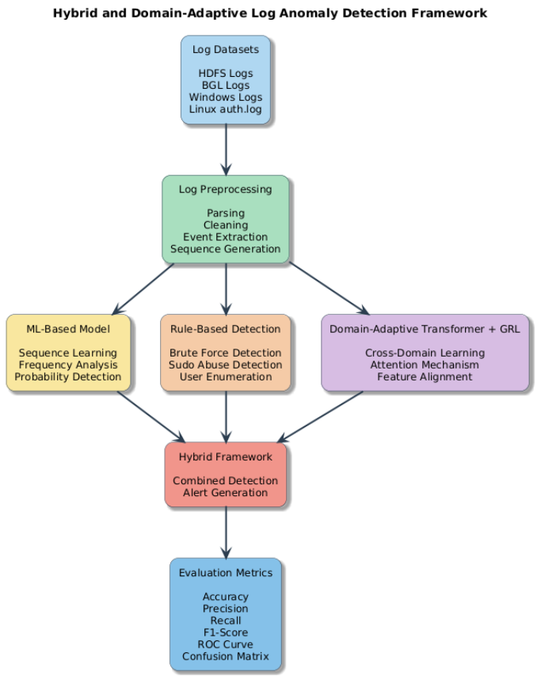
Figure 1: Overall architecture of the proposed hybrid and domain-adaptive log anomaly detection framework integrating preprocessing, machine learning, rule-based analysis, and Transformer-based cross-domain anomaly detection.

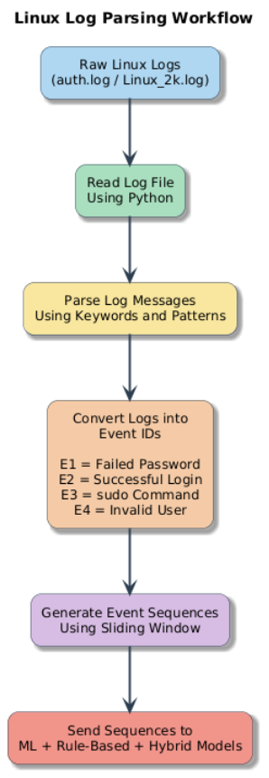
Figure 2: Linux log parsing and preprocessing workflow for anomaly detection.

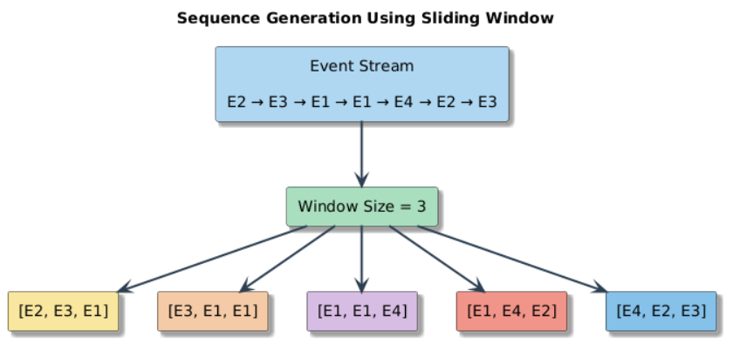
Figure 3: Sliding window-based sequence generation from parsed log events.

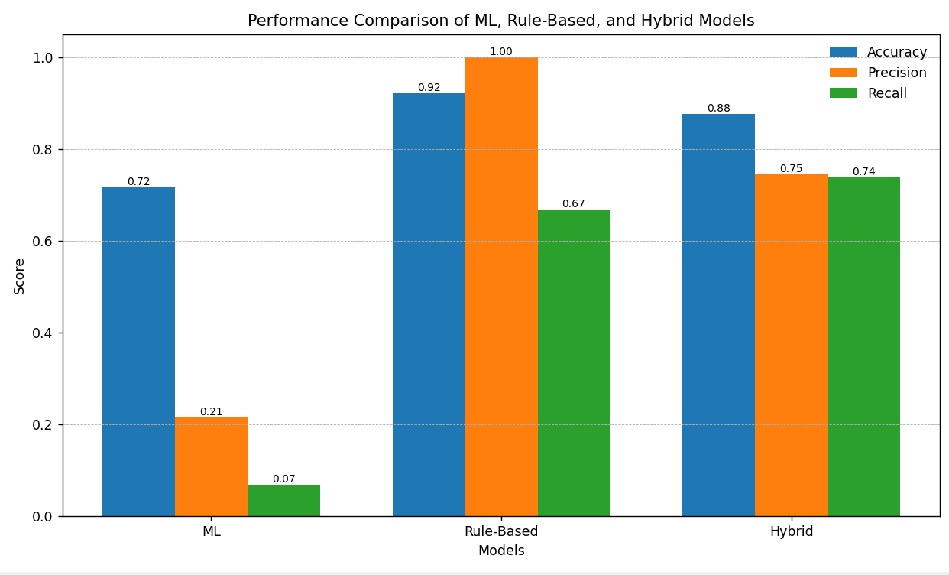
Figure 4: Comparative performance analysis of machine learning, rule-based, and hybrid anomaly detection models using accuracy, precision, and recall metrics. 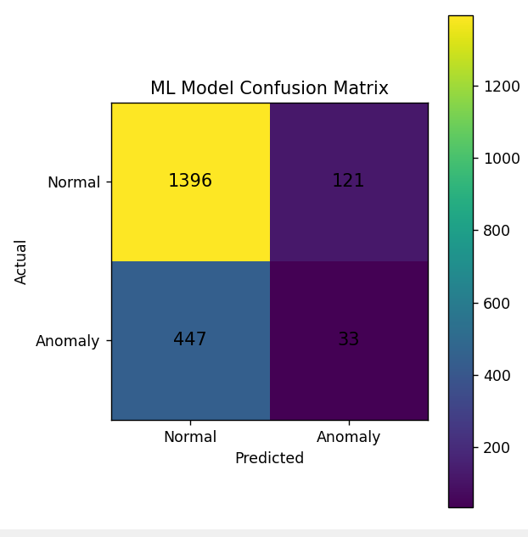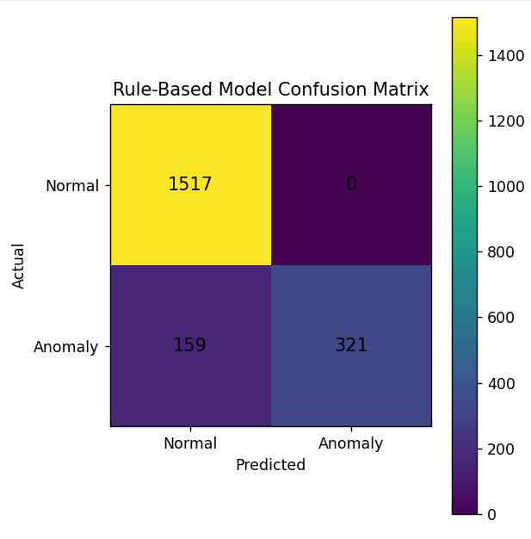
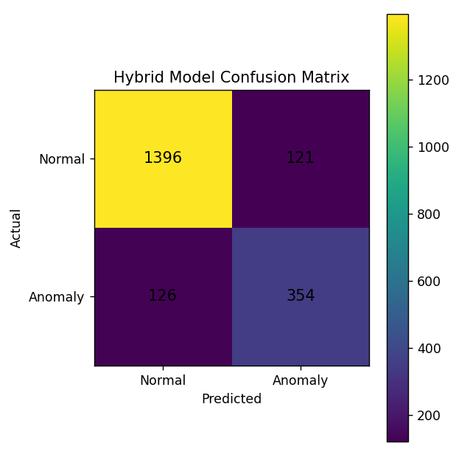
Figure 5: Confusion Matrices

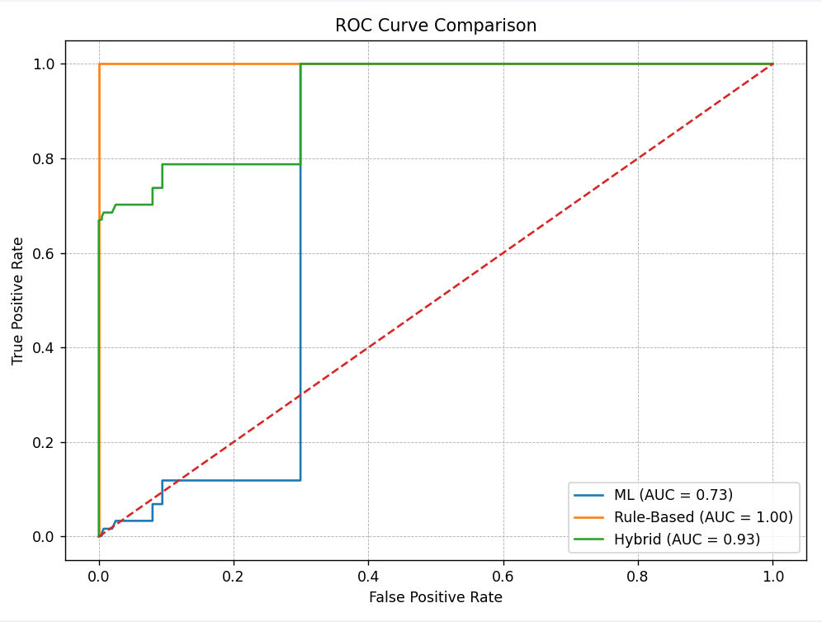
Figure 6: ROC Curve Comparison

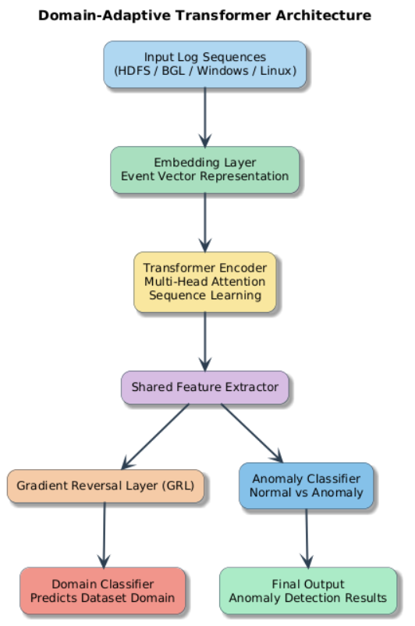
Figure 7: Domain-Adaptive Transformer architecture integrating Gradient Reversal Layer (GRL) for cross-system log anomaly detection.

11. DISCUSSION
The project demonstrates that:
- Traditional ML alone is insufficient for robust anomaly detection.
- Rule-based systems provide strong precision but may miss unseen attacks.
- Hybrid approaches improve balanced detection.
- Domain adaptation is essential for cross-system generalization.
The Linux implementation provided practical cybersecurity understanding, while Transformer experiments demonstrated advanced deep learning capabilities.

12. LIMITATIONS
Some limitations include:
- Heuristic labels for certain datasets
- Limited real-time deployment
- Dataset imbalance
- Frequency-based ML limitations

13. FUTURE WORK
Future improvements may include:
- Real-time streaming anomaly detection
- Self-supervised learning
- Federated anomaly detection
- Transformer-LSTM hybrids
- SIEM integration
- Cloud deployment

14. CONCLUSION
This project presented a comprehensive study and implementation of log anomaly detection using multiple approaches ranging from traditional rule-based detection to advanced domain-adaptive Transformers.
The Linux-based implementation successfully demonstrated practical anomaly detection using machine learning and cybersecurity rules. The Transformer-based framework further demonstrated the importance of domain adaptation in achieving strong cross-system performance.
The study concludes that combining:
- Machine learning
- Rule-based security intelligence
- Deep learning
- Domain adaptation
creates a scalable and effective framework for modern log anomaly detection systems.
REFERENCES

[1] M. Du, F. Li, G. Zheng, and V. Srikumar, “DeepLog: Anomaly detection
and diagnosis from system logs through deep learning,” in Proc. ACM
CCS, 2017, pp. 1285–1298.
[2] W. Meng, Y. Liu, Y. Zhu, S. Zhang, and D. Pei, “LogAnomaly:
Unsupervised detection of sequential and quantitative anomalies in
unstructured logs,” in Proc. IJCAI, 2019, pp. 4739–4745.
[3] H. Zhang, M. Du, F. Li, and V. Srikumar, “LogRobust: Robust log-based
anomaly detection on unstable log data,” in Proc. ACM SIGKDD, 2019,
pp. 807–817.
[4] J. Guo, X. Lin, and H. Zhang, “LogBERT: Log anomaly detection via
BERT,” in Proc. Int. Joint Conf. Neural Networks (IJCNN), 2021, pp.
1–8.
[5] P. He, J. Zhu, S. He, J. Li, and M. R. Lyu, “Drain: An online log parsing
approach with fixed depth tree,” in Proc. IEEE ICWS, 2017, pp. 33–40.
[6] M. Du and F. Li, “Spell: Streaming parsing of system event logs,” in
Proc. IEEE ICDM, 2016, pp. 859–864.
[7] F. T. Liu, K. M. Ting, and Z.-H. Zhou, “Isolation forest,” in Proc. IEEE
ICDM, 2008, pp. 413–422.
[8] C. Xu, S. Zhang, Y. Zhu, W. Meng, X. Liu, and D. Pei, “LogPAI: A
benchmark for log parsing and anomaly detection,” in Proc. IEEE/IFIP
DSN, 2020, pp. 371–382.
[9] Q. Lin, H. Zhang, J. Lou, Y. Zhang, and X. Chen, “Log clustering based
problem identification for online service systems,” in Proc. IEEE ICSE,
2016, pp. 102–111.
[10] S. He, J. Zhu, P. He, and M. R. Lyu, “Experience report: System
log analysis for anomaly detection,” in Proc. IEEE ISSRE, 2016, pp.
207–218.
[11] Y. Liu, W. Meng, Y. Zhu, and D. Pei, “Unsupervised log anomaly
detection using recurrent neural networks,” in Proc. IEEE/IFIP DSN
Workshops, 2018, pp. 1–6.

